Practical Task from Generation-Next IT Solution Limited.

Position : .NET Programmer

Applicant Name : Rakibul Islam

Applicant Email : [rakib33mbstu@gmail.com](mailto:rakib33mbstu@gmail.com)

Applicant Phone : +8801920202882

Task : Meeting Minutes

**Task Details**:

**First Part:**

1. According given UI Customer Name will be loaded in drop down list based on radio button selection “Corporate” and “Individual”. Corporate Customer will be loaded from Database Table named ’Corporate_Customer_Tbl’ and Individual Customer will be loaded from Database Table named ‘Individual_Customer_Tbl’.
2. Date will be selected from bootstrap calendar, Time will be 12 Hours Format such as 9:10 AM, 3:20 PM.

**Second Part:**

1. Select Product/Service dropdown list will be loaded from a Database Table named ‘Products_Service_Tbl’, unit will be loaded based on Selected Product/Service option inread only textbox, Quantity(input only numeric value.
2. ‘Add’ button will add these data to below bootstrap table. Any number of rows can be added to this table. Added

rows can be edited or deleted.

**Third Part:**

1. ‘Save’ button will save First Part data in table ‘Meeting_Minutes_Master_Tbl’ using stored procedure ‘Meeting_Minutes_Master_Save_SP’ and
2. Second Part data in table‘Meeting_Minutes_Details_Tbl’ using stored procedure ‘Meeting_Minutes _Details_Save_SP’.

**Guide Line:**

Use ASP.Net, HTML, Bootstrap, and JQuery as client side programming language, C #as Server side programming language and MS SQL Server as database.

**UI**

1. According Guideline Form UI using Bootstrap looks like bellow
2. 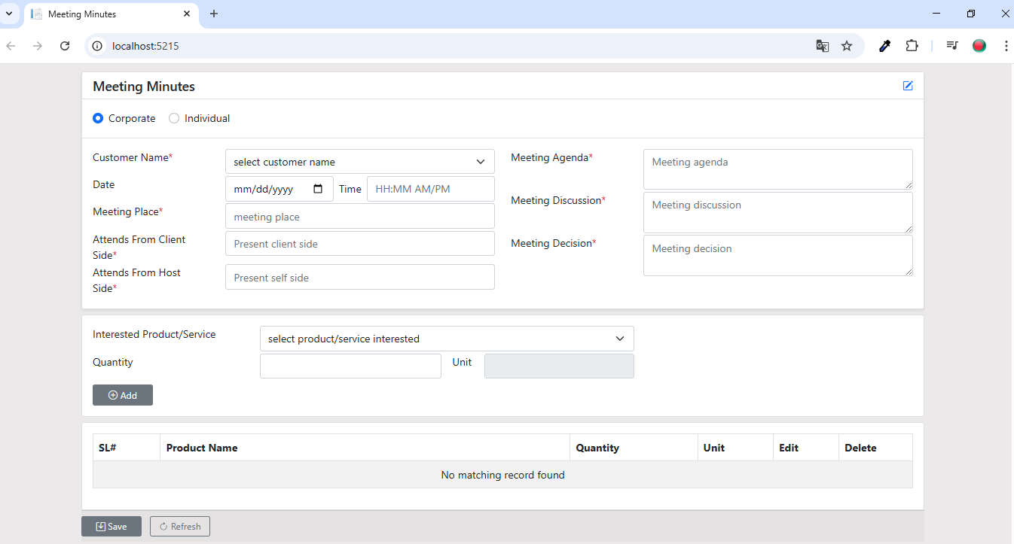Form Validation UI looks like :

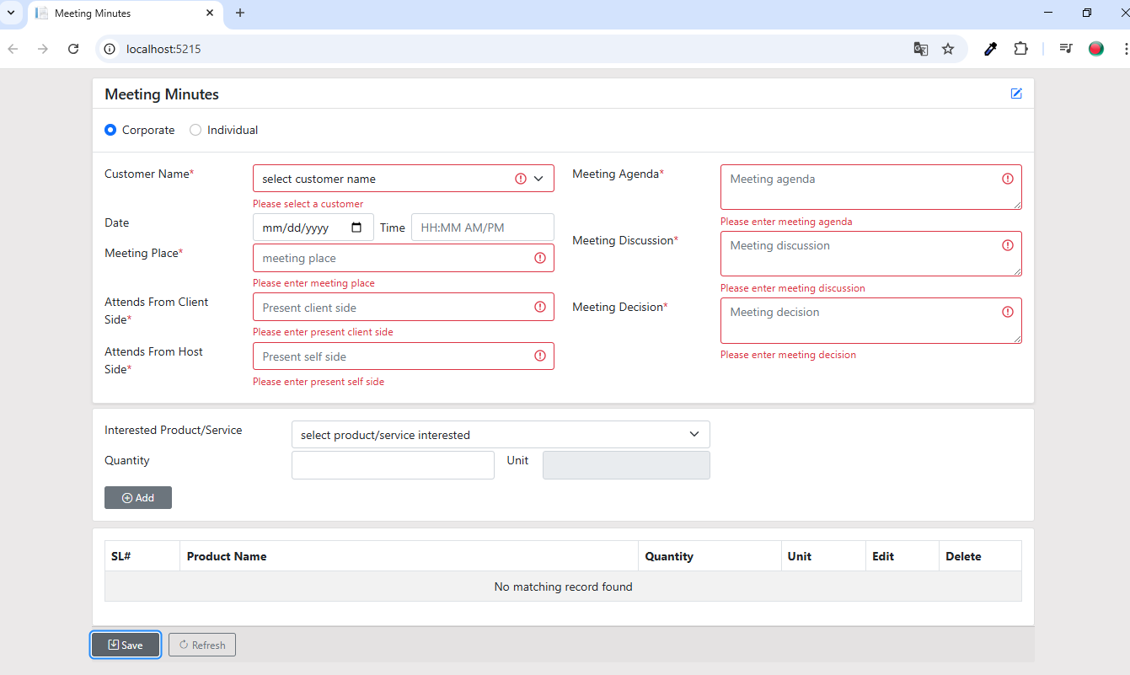

1. Add Interested Product from drop down. Read only field Unit will auto update based on selected product.

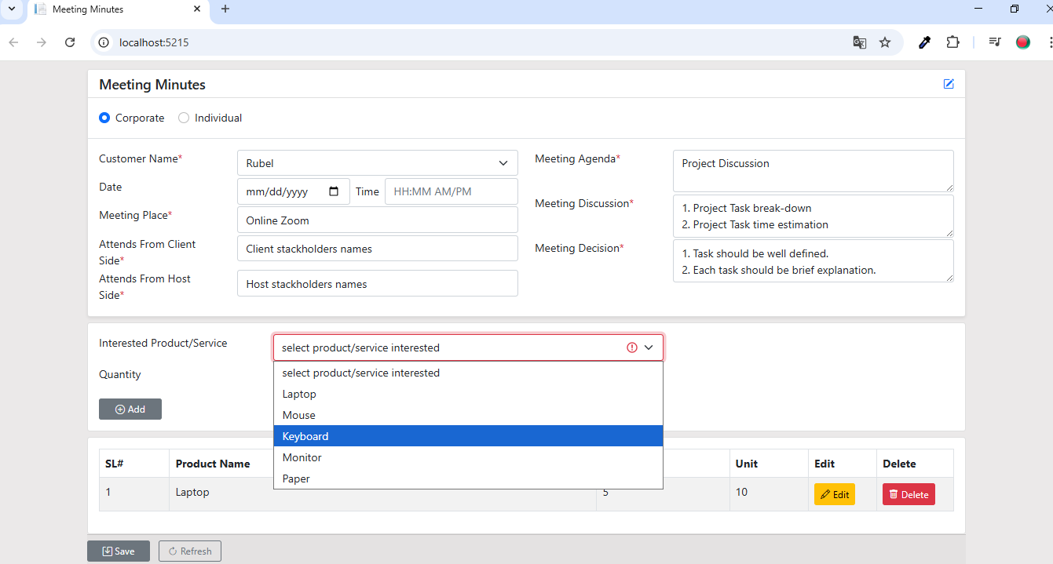

1. Product Edit. After click Edit button from dynamic table data can be changeable from product add section.

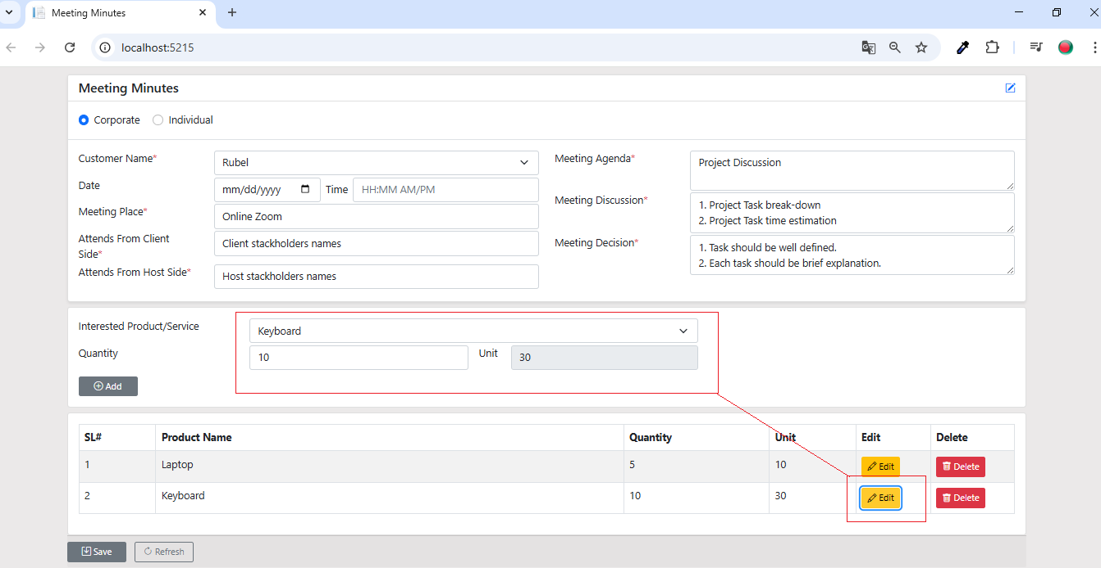

1. 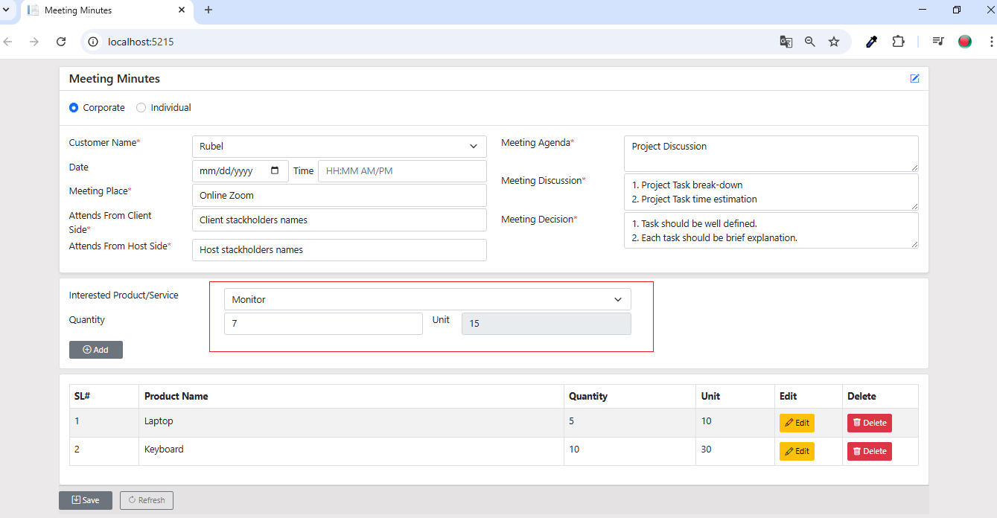Change Keyboard to Monitor and Quantity 10 to 7. And then click Add button.
2. Product will be edited in the specific table index.

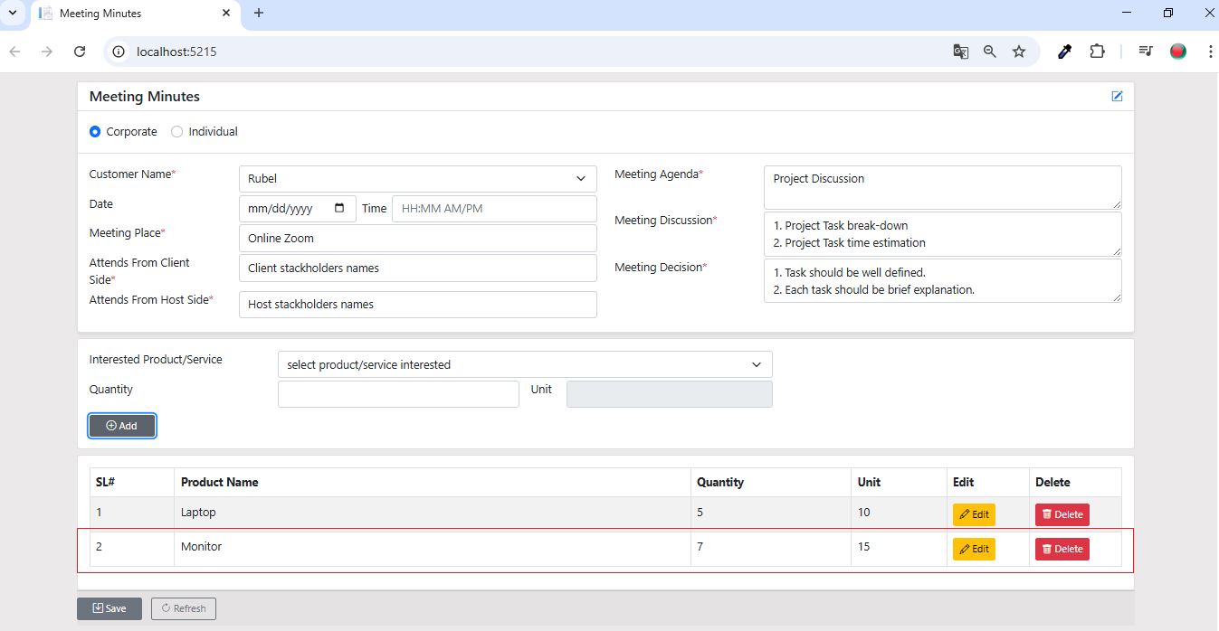

1. Delete Monitor Product from dynamic table by Clicking Delete Button. An Alert popup Confirm box will appear and asked to make sure to delete or cancel.

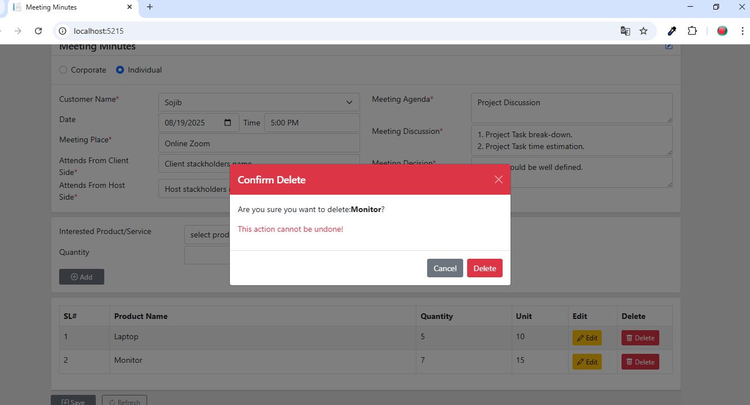

1. After Click Delete button from confirm alert box product will be deleted and table will be updated. A toaster notification alert will show bottom of the page with delete notification message.

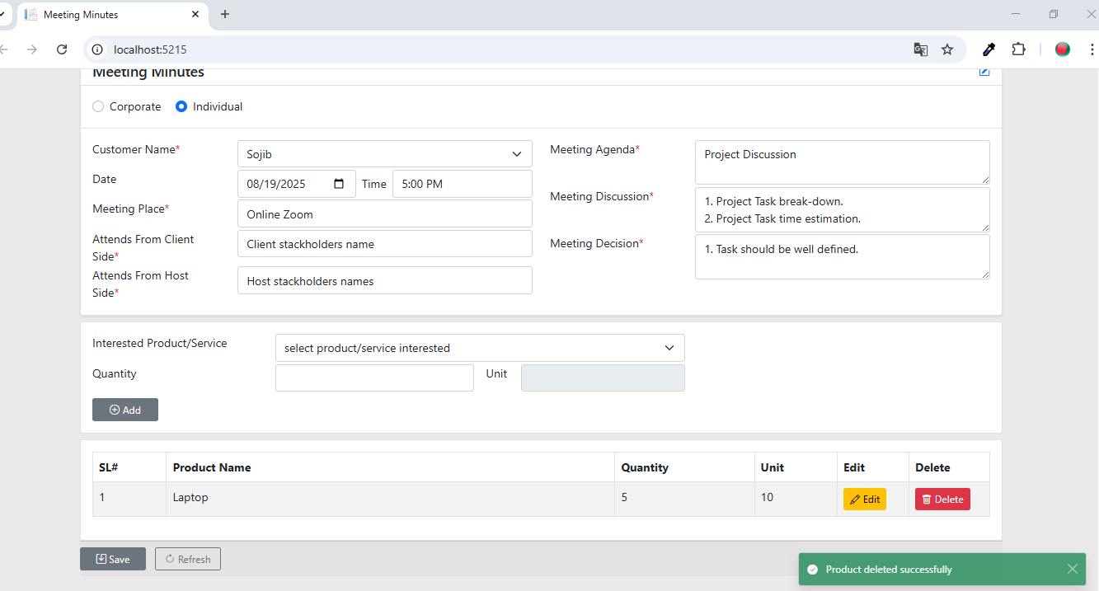

1. 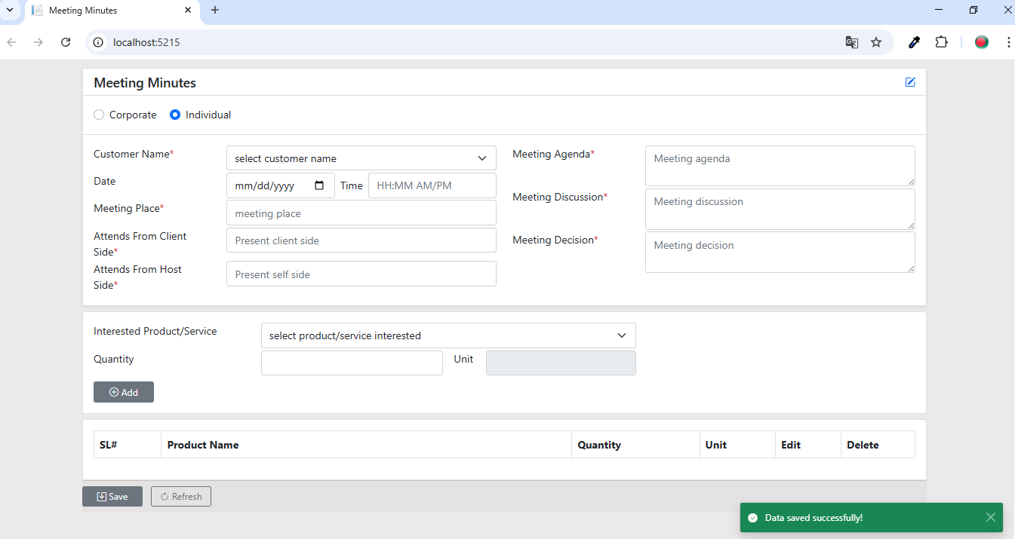Click the Save button. Data will be saved , Form will be refreshed and saved bootstrap toaster notification will display
2. Bootstrap Date picker looks like.

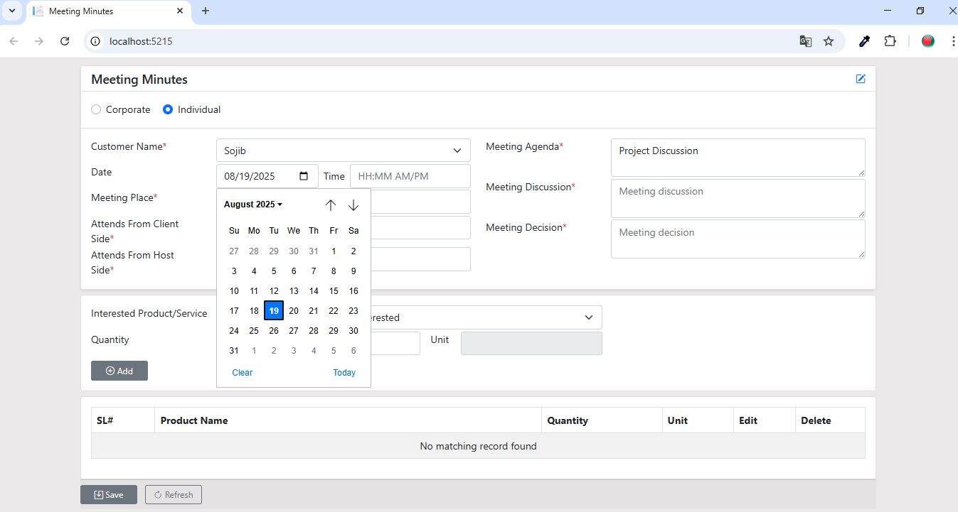

1. Mobile friendly page responsiveness.

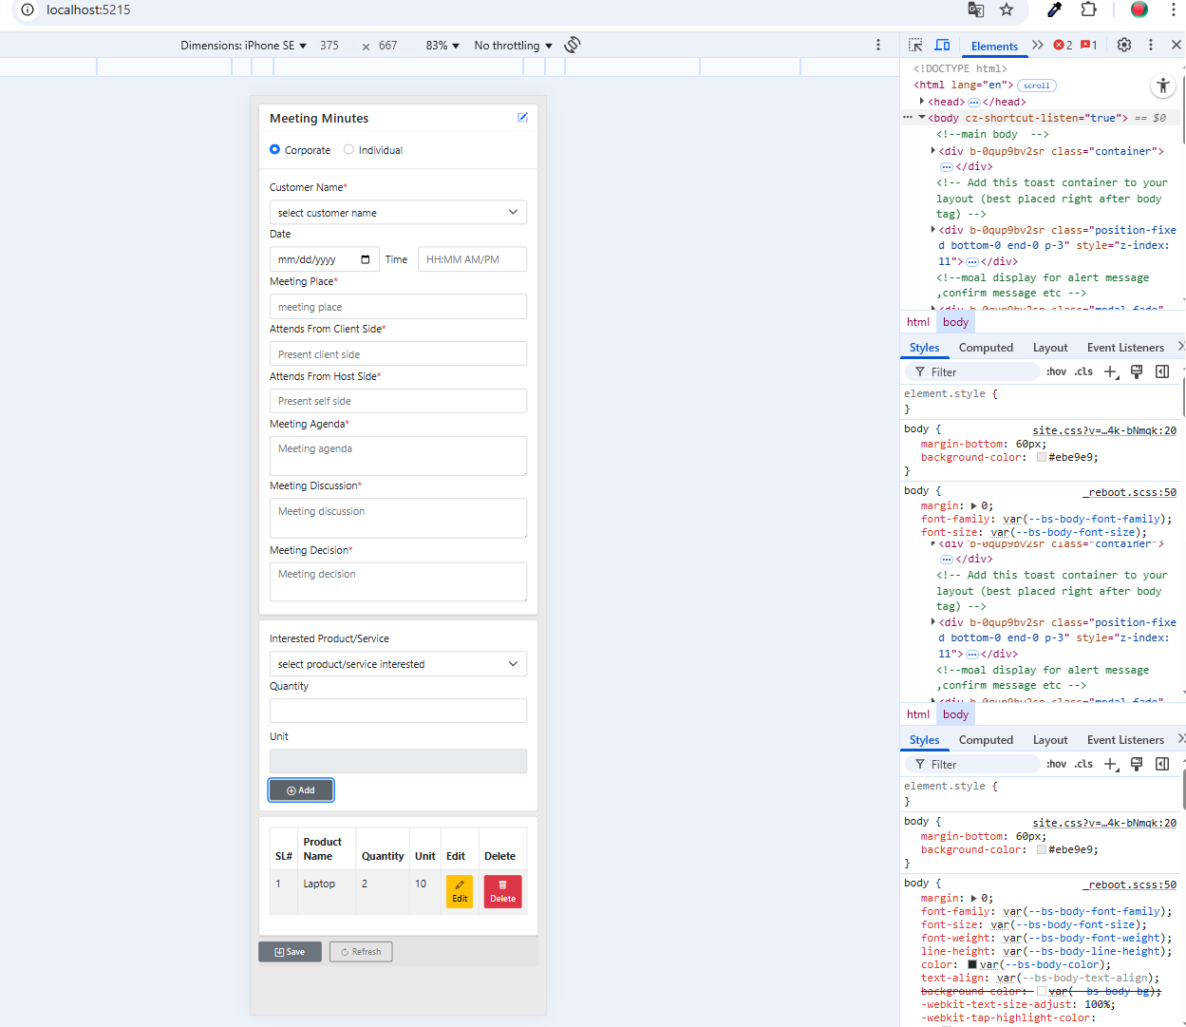

1. Bootstrap and JQuery Time picker 12 hours format.

